**Buttons in HTML**

**When button is inside form**

**1.If type attribute is set to button**

**Result – when button is click nothing will happen**

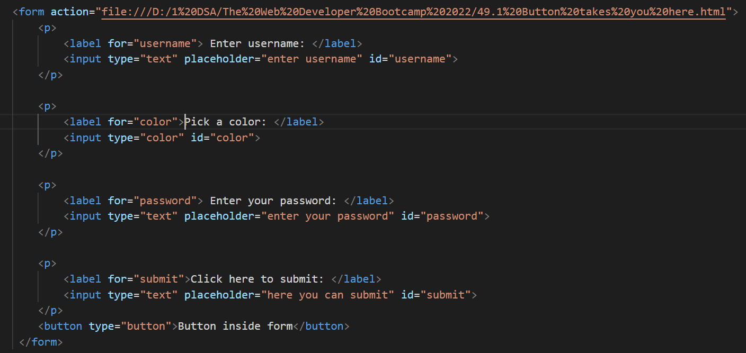

**2.If type attribute is set to submit or blank**

**Result – when button is clicked you will be redirected to page that link is given in action attribute of form**

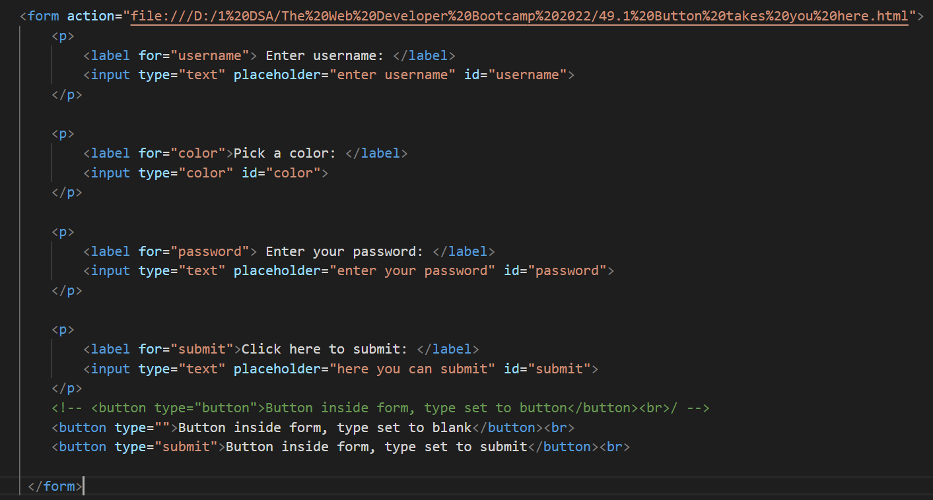

**When button is outside form**

**Result – when button is click nothing will happen whatever the type is (we have to associate it)**

**Button Attributes**

